EE 5356- DIGITAL IMAGE PROCESSING

ASSIGNMENT 3B

BY

PAVAI ARCHIMEDES

1001233996

SOLUTION;

MATLAB PROGRAM:

clc;

clear all;

close all;

org_image=fopen('C:\Users\PAVAI ARCHIMEDES\Desktop\girl.png');

vumng_im = fread(org_image);% read the image

pis = 256*256*3;

for i = 1:256

for j = 1:256

R_cp(i,j) = vumng_im((i-1)*256*3+(j-1)*3+1);

G_cp(i,j) = vumng_im((i-1)*256*3+(j-1)*3+2);

B_cp(i,j) = vumng_im((i-1)*256*3+(j-1)*3+3);

end

end

figure(1);

% display the red component of raw image

subplot(3,3,1);

image(uint8(R_cp));

title('Red Component of the RAW image');

% display the green component of image

subplot(3,3,2);

image(uint8(G_cp));

title('Green Component of the RAW image');

% displaying the blue component of raw image

subplot(3,3,3);

image(uint8(B_cp));

title('Blue Component of the RAW image');

% manipulating y i q

Ytt = 0.299*R_cp+0.587*G_cp+0.114*B_cp;

kkk = 0.596*R_cp-0.274*G_cp-0.322*B_cp;

jjj = 0.211*R_cp-0.523*G_cp+0.312*B_cp;

subplot(3,3,4);

image(uint8(Ytt));

title('Y Component of the RAW image');

subplot(3,3,5);

image(uint8(kkk));

title('I Component of the RAW image');

subplot(3,3,6);

image(uint8(jjj));

title('Q Component of the RAW image');

R_cl = Ytt+0.956*kkk+0.621*jjj

G_cl = Ytt-0.272*kkk-0.647*jjj

B_cl = Ytt-1.106*kkk+1.703*jjj

subplot(3,3,7);

image(uint8(R_cl));

title('Red Reconstructed');

subplot(3,3,8);

image(uint8(G_cl));

title('Green Reconstructed');

subplot(3,3,9);

image(uint8(B_cl));

title('Blue Reconstructed');

original_image(:,:,1) = R_cp;

original_image(:,:,2) = G_cp;

original_image(:,:,3) = B_cp;

figure(2);

image(uint8(original_image));

title('original image');

% flowers

clc;

clear all;

close all;

vumng = imread('C:\Users\PAVAI ARCHIMEDES\Desktop\flowers.bmp');

figure(1);

imshow(vumng);

title('original image');

vumng = double(vumng);

pis = 500*362*3;

R_cp = vumng(:,:,1);

G_cp = vumng(:,:,2);

B_cp = vumng(:,:,3);

figure(2);

subplot(3,3,1);

image(uint8(R_cp));

title('Red Component');

subplot(3,3,2);

image(uint8(G_cp));

title('Green Component');

subplot(3,3,3);

image(uint8(B_cp));

title('Blue Component');

Y = (G_cp+(R_cp+B_cp)/2)/2;

Cg = (G_cp-(R_cp+B_cp)/2)/2;

Co = (R_cp-B_cp)/2;

subplot(3,3,4);

image(uint8(Y));

title('Y Component');

subplot(3,3,5);

image(uint8(Cg));

title('Cg Component');

subplot(3,3,6);

image(uint8(Co));

title('Co Component');

R_cl = Y+Co-Cg;

G_cl = Y+Cg;

B_cl = Y-Co-Cg;

subplot(3,3,7);

image(uint8(R_cl));

title('Red Reconstructed');

subplot(3,3,8);

image(uint8(G_cl));

title('Green_Reconstructed');

subplot(3,3,9);

image(uint8(B_cl));

title('Blue Reconstructed');

RESULTS:  
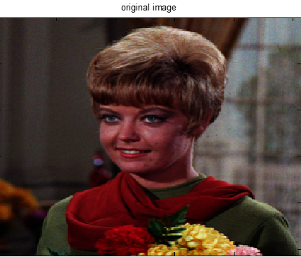







CONCLUSION:

* Here using the R G B color components Y( luminance) I( chrominance) Q components are obtained.
* Color space conversion and inverse color space conversion is also completed.